1. **Agenda**:
   1. Enable auto-configuration logging for debugging purpose.
2. application.properties  
   debug=true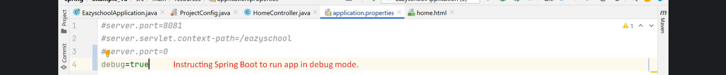
3. Text

   Description automatically generated with medium confidence
4. Text

   Description automatically generated
5. So, beans and properties are auto-configured.
6. Text

   Description automatically generated with low confidence
7. 
8. A picture containing text

   Description automatically generated
9. Graphical user interface, text, application

   Description automatically generated
10. Graphical user interface, text, application

    Description automatically generated